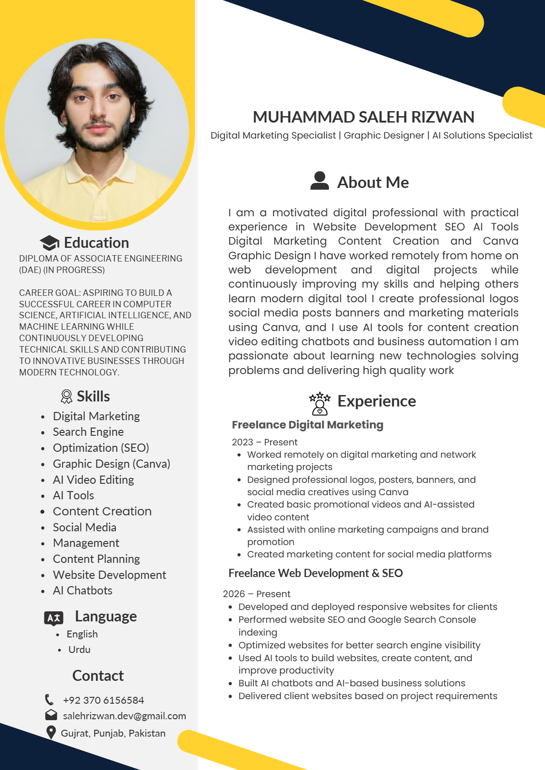
MUHAMMAD SALEH RIZWAN
Digital Marketing Specialist | Graphic Designer | AI Solutions Specialist
About Me
I am a motivated digital professional with practical
experience in Website Development SEO AI Tools
Digital Marketing Content Creation and Canva
Education
Graphic Design I have worked remotely from home on
DIPLOMA OF ASSOCIATE ENGINEERING
(DAE) (IN PROGRESS) web development and digital projects while
continuously improving my skills and helping others
CAREER GOAL: ASPIRING TO BUILD A
learn modern digital tool I create professional logos
SUCCESSFUL CAREER IN COMPUTER
social media posts banners and marketing materials
SCIENCE, ARTIFICIAL INTELLIGENCE, AND
MACHINE LEARNING WHILE
using Canva, and I use AI tools for content creation
CONTINUOUSLY DEVELOPING
video editing chatbots and business automation I am
TECHNICAL SKILLS AND CONTRIBUTING
passionate about learning new technologies solving
TO INNOVATIVE BUSINESSES THROUGH
problems and delivering high quality work
MODERN TECHNOLOGY.
Skills
Experience
Digital Marketing
Freelance Digital Marketing
Search Engine
2023 – Present
Optimization (SEO)
Worked remotely on digital marketing and network
Graphic Design (Canva)
marketing projects
Designed professional logos, posters, banners, and
AI Video Editing
social media creatives using Canva
AI Tools
Created basic promotional videos and AI-assisted
Content Creation
video content
Social Media
Assisted with online marketing campaigns and brand
promotion
Management
Created marketing content for social media platforms
Content Planning
Freelance Web Development & SEO
Website Development
AI Chatbots
2026 – Present
Developed and deployed responsive websites for clients
Language
Performed website SEO and Google Search Console
indexing
English
Optimized websites for better search engine visibility
Urdu
Used AI tools to build websites, create content, and
improve productivity
Contact
Built AI chatbots and AI-based business solutions
Delivered client websites based on project requirements
+92 370 6156584
salehrizwan.dev@gmail.com
Gujrat, Punjab, Pakistan

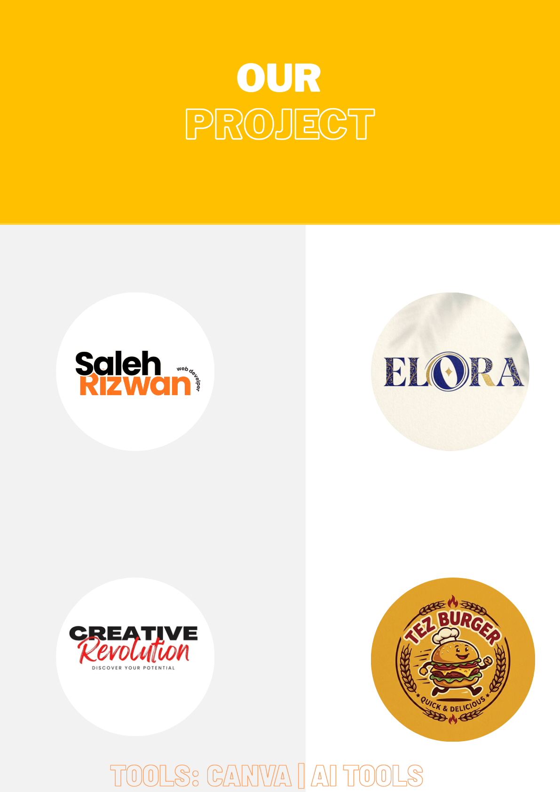
OUR
PROJECT PROJECT
TOOLS: CANVA | AI TOOLS TOOLS: CANVA | AI TOOLS

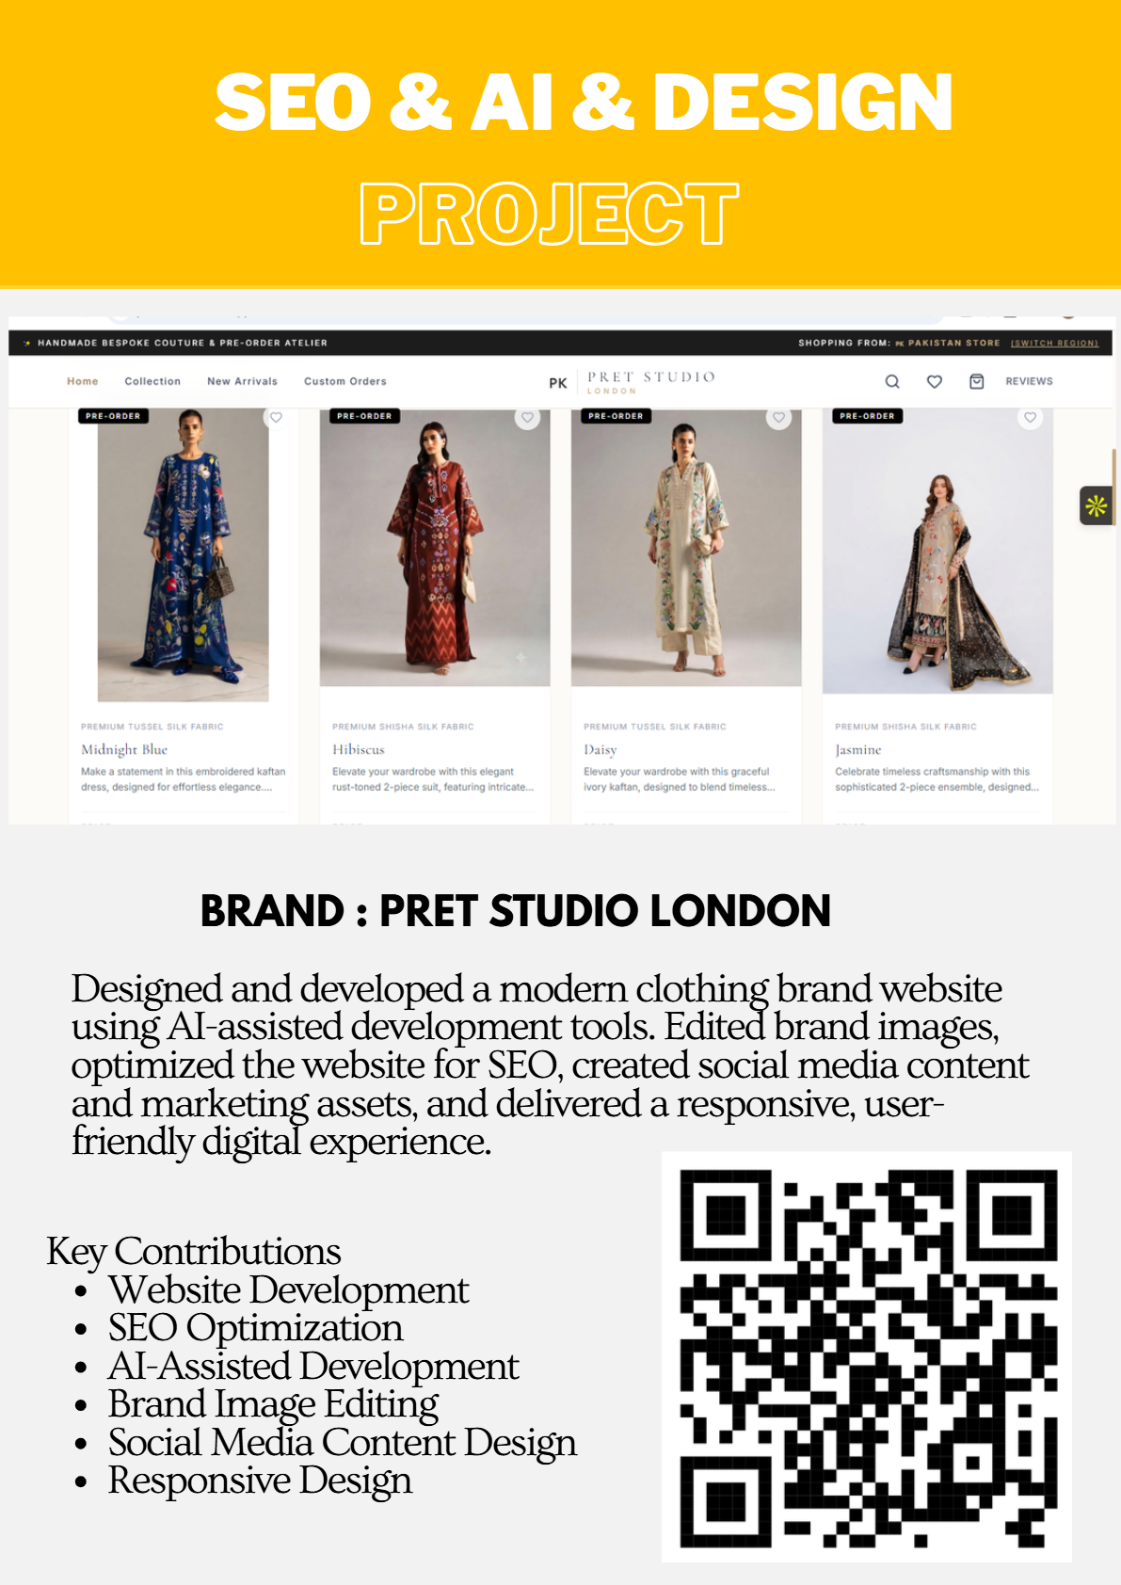
SEO & AI & DESIGN
PROJECT PROJECT
BRAND : PRET STUDIO LONDON
Designed and developed a modern clothing brand website
using AI-assisted development tools. Edited brand images,
optimized the website for SEO, created social media content
and marketing assets, and delivered a responsive, user-
friendly digital experience.
Key Contributions
Website Development
SEO Optimization
AI-Assisted Development
Brand Image Editing
Social Media Content Design
Responsive Design

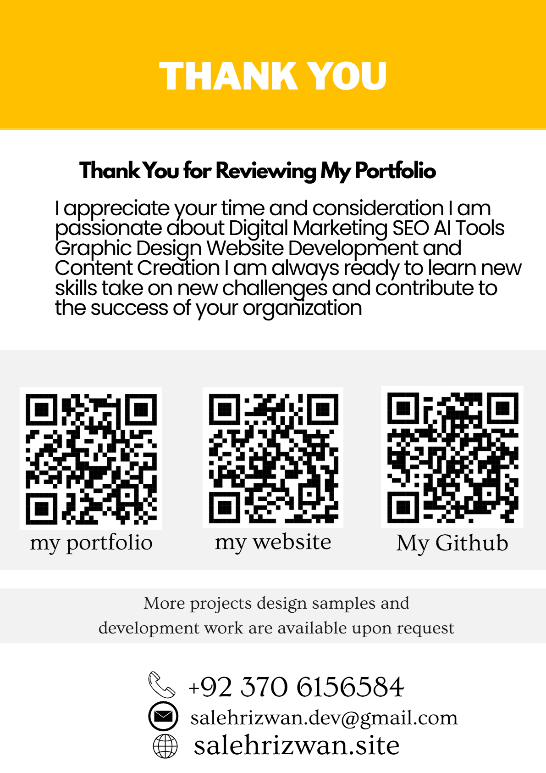
THANK YOU
Thank You for Reviewing My Portfolio
I appreciate your time and consideration I am
passionate about Digital Marketing SEO AI Tools
Graphic Design Website Development and
Content Creation I am always ready to learn new
skills take on new challenges and contribute to
the success of your organization
my portfolio my website
My Github
More projects design samples and
development work are available upon request
+92 370 6156584
salehrizwan.dev@gmail.com
salehrizwan.site

